Sunday, July 12, 2015 / 5 p.m. – Sunday, July 19, 2015/1 p.m.

8 DAY DIRECTED RETREAT
Directors: Chris Machado SSS, Ingrid Honore-Lallande CSJ, Pat Nelson CSJ,
Jane DeLisle, CSJO, Barbara Sullivan CSJ,

God invites and inspires individuals to come aside to a secluded place and rest a while (Mk 6:30-32).
A Directed Retreat is a time to set aside the normal occupations and preoccupations of daily life, and take the time to grow quiet, to center, and to listen for God in all the ways God may speak. In daily meetings with the retreatant, a spiritual companion listens to and encourages retreatants to give voice to their experience in prayer and to come to a deeper perception and understanding of that experience. One needs to have experience in prayer, the ability to enter into silence, and enough openness and trust to share these experiences with their director.
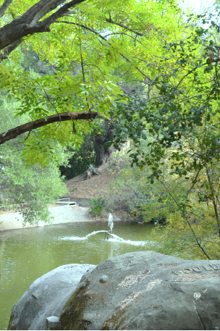
Pre-requisite: previous experience of a silent retreat
Contact: Pat Nelson, CSJ, 818-784-4515 ext. 3870.
Message Therapy will be available
Fee: $500 – private room
$50 deposit(non-refundable) required with registration by June 15, 2015

Early registration recommended as space is limited
Holy Spirit Retreat Center
4316 Lanai Road Encino CA 91436
Phone: 818-784-4515 Fax: 818-784-0409
www.hsrcenter.com hsrcenter@earthlink.net
xxxxxxxxxxxxxxxxxxxxxxxxxxxxxxxxxxxxxxxxxxxCUT & SENDxxxxxxxxxxxxxxxxxxxxxxxxxxxxxxxxxxxx

8-day Intensive Centering Prayer Retreat – 6/28; 5p.m.- 7/5/2015; 1p.m.
______$50 deposit or _____$500 (enclosed) by 6/1/13
Name____________________________________Phone (_______)______________
Address_______________________________________________________________
City_______________________________________State_____Zip________________
Email_________________________________________________________________

